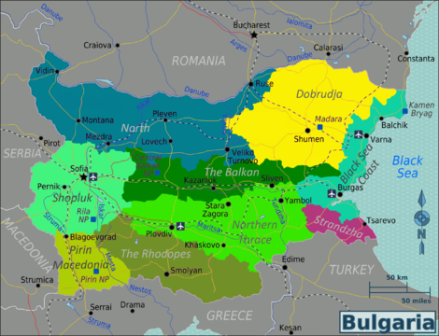
ŠOPSKO LITO

ORIGIN Šopluk. This dance can be seen done in the “krâčma” the bar, pub, saloon. Therefor the hand hold is hooked in and steps are small and modest. The music used is the song: Rada, Radomirka by Georgi Gyulski.

SOURCE Dilyana Kurdova, 2015

METER 2/4

INTRODUCTION With the used recording it can be: 32 bars

STARTING POSITION Open circle, l hand at the side,
R arms hooked in L arm of neighbor.
R wrist rests on top of L wrist of neighbor

MEAS CT PART 1

1 1-2 Step on R sdwd R and step on L across in front of R
2 1-2 Repeat: Step on R sdwd R and step on L across in front of R
3 1-2 Big step R and hold
4 1-2 Step on L fwd twd ctr and hold
5 1-2 Step on R back in place
6 1-2 Step on L sdwd L and step on R across in front of L
7 1-2 Step on L sdwd L and step on R across behind L
8 1-2 Step on L sdwd turning body slightly in LOD, keeping R on the fl
9 1-2 Shift weight onto R, turning body slightly RLOD, keeping L on the fl
10 1-2 Shift weight onto L, turning body slightly in LOD, keeping R on the fl

Dance notation: Bianca de Jong © 2015

